**Lab6- WebApi_Handson**

Amrita Kumari 6362289

**Kafka Integration with C#:**

Apache Kafka is a distributed event streaming platform used for high-performance data pipelines, streaming analytic, data integration, and mission-critical applications. It allows:

* Producers to send data (messages),
* Topics to categorize the data,
* Consumers to read it.

**Kafka Architecture Overview**

* Producer: Sends messages to a topic.
* Topic: Logical channel for messages.
* Partition: Sub-division of a topic for load balancing.
* Broker: Kafka server storing data.
* Consumer: Reads messages from topics.
* Zookeeper: Manages Kafka brokers and cluster coordination.

**Starting Zookeeper:**

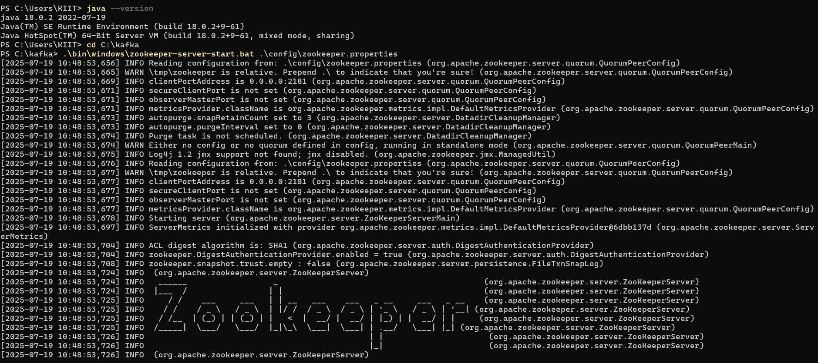

**Starting Kafka Server:**

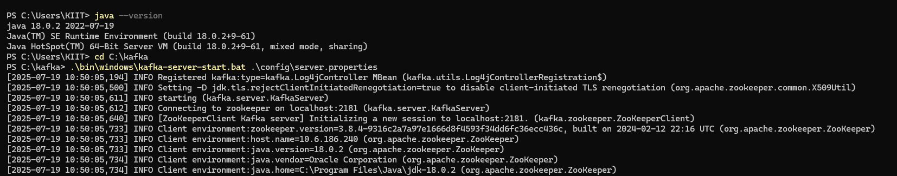

**Creating a Kafka Topic:**

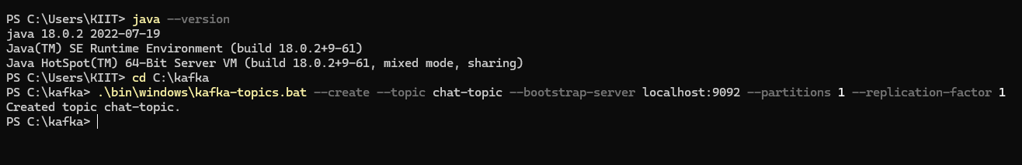

**Solution directory for hands on 1:**

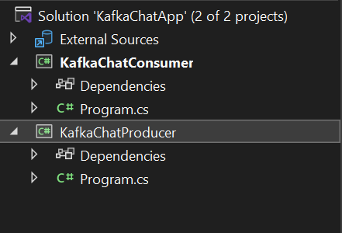

1. **Creating a Chat Application which uses Kafka as a streaming platform and consuming the chat messages in the command prompt’s output.**

**Chat in Producer**

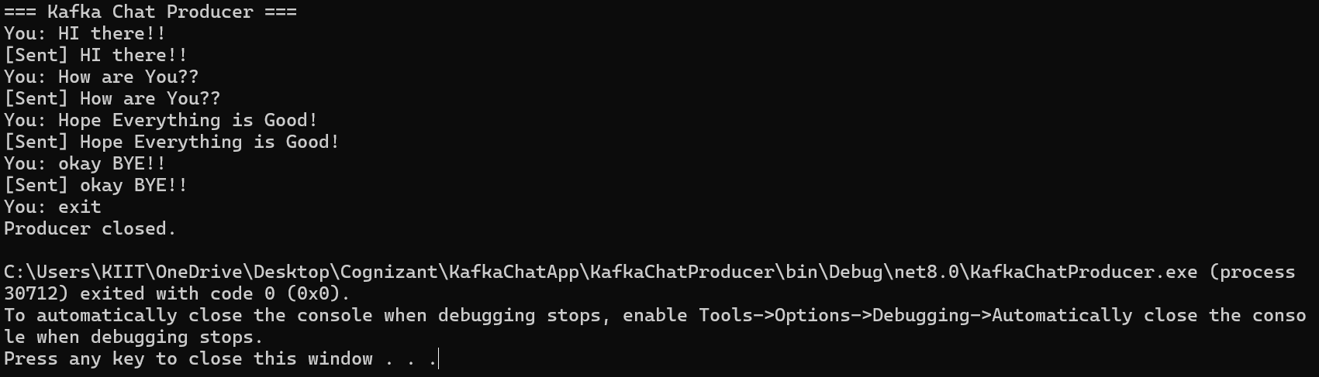

**Output in Consumer**

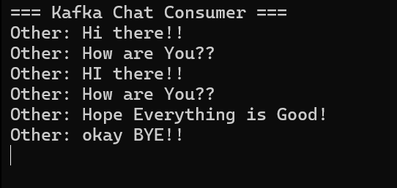

1. **Create a Chat Application using C# Windows Application using Kafka and consume the message in different client applications.**

**Chat client**

